**Assignment 1**



**Submitted to:**

Ma’am Yasmeen Jana

**Submitted by:**

Muhammad Faizan

**Registration no:**

FA22-BSE-052

**Course:**

Web Technologies

**“Department of Computer Science”**

**COMSATS University Islamabad,**

**“Vehari Campus”**

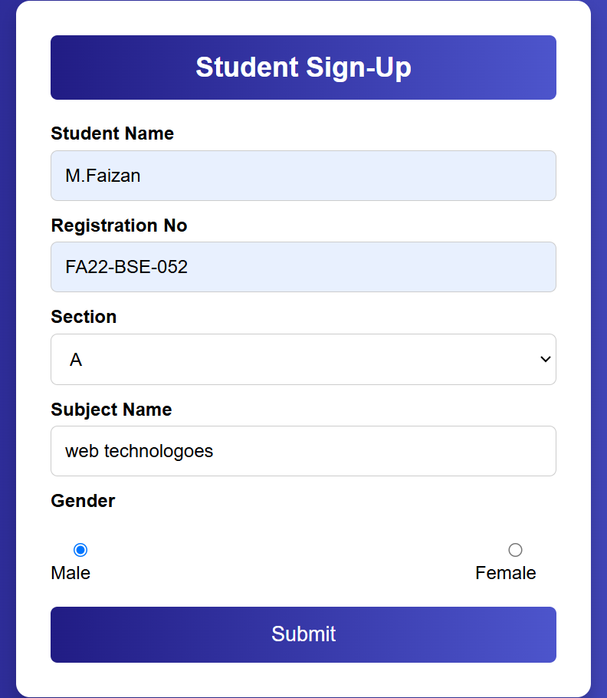

**Front Page:**

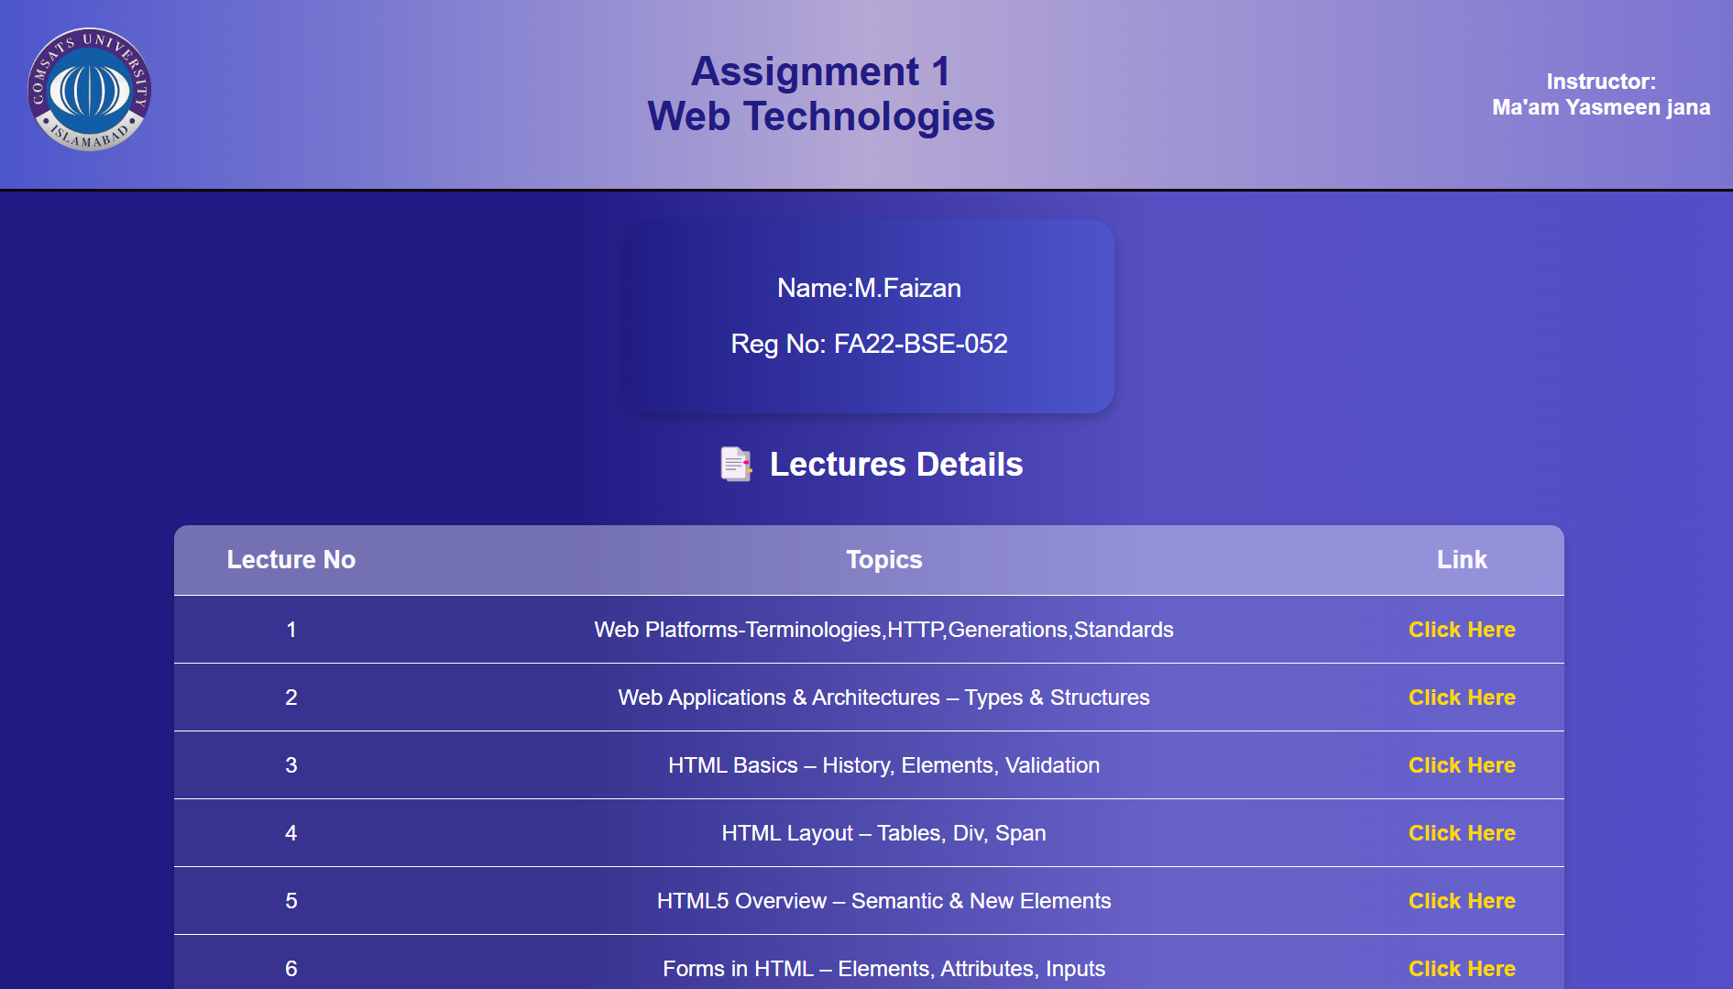

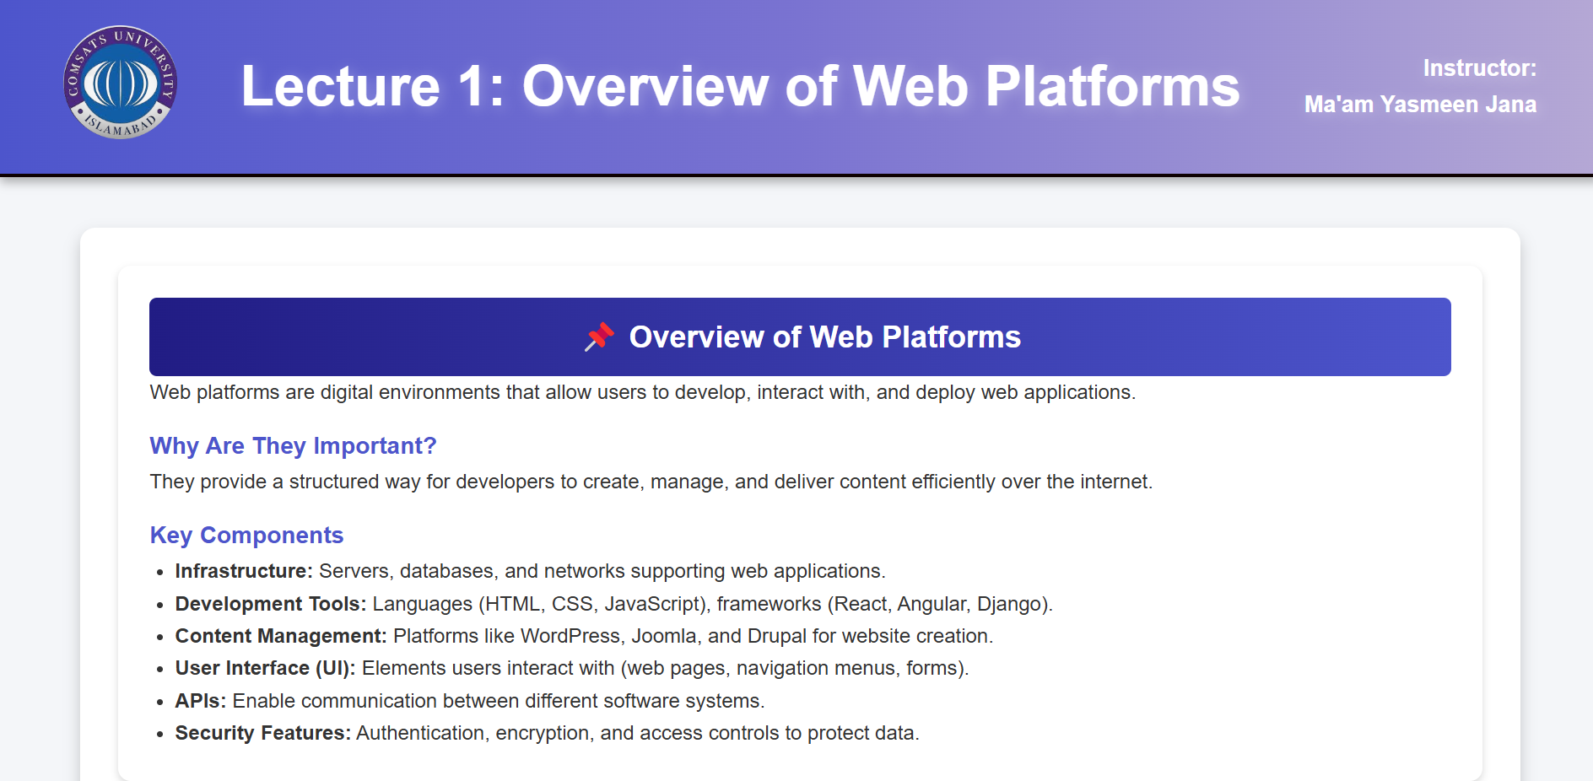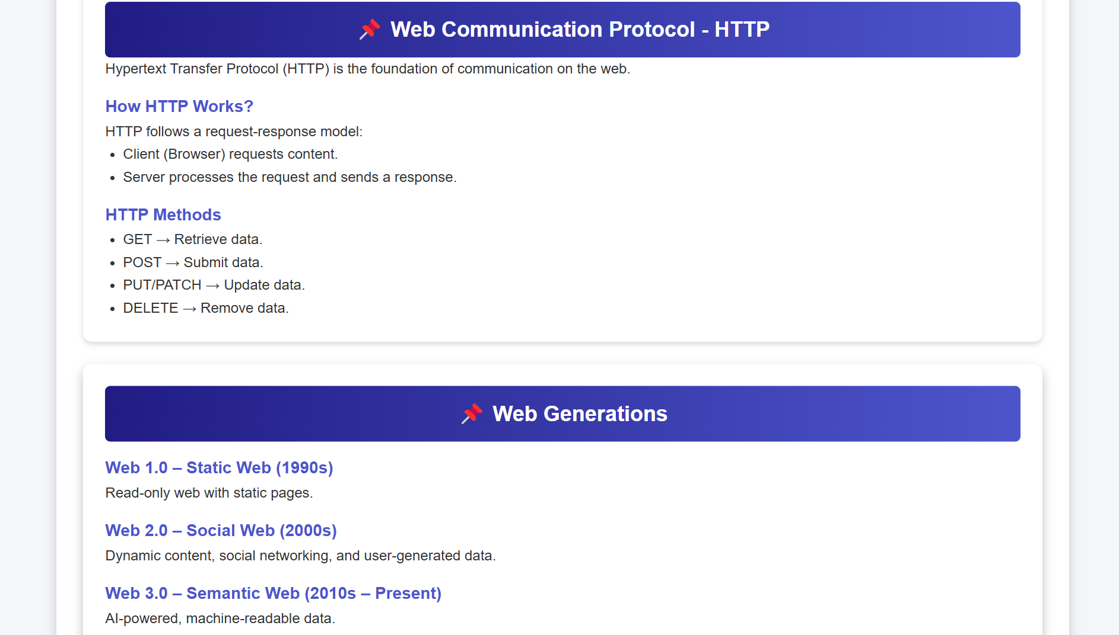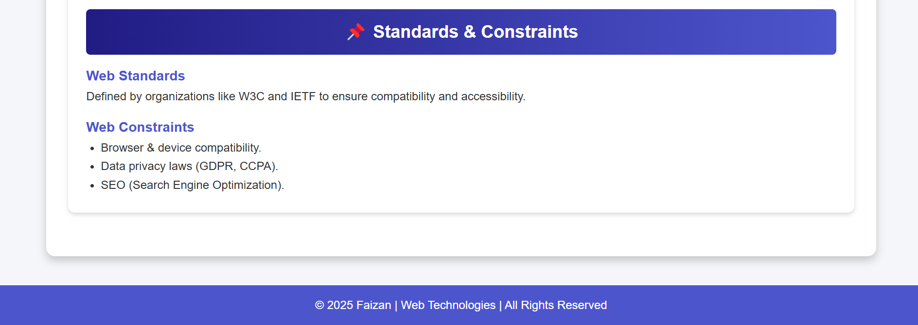

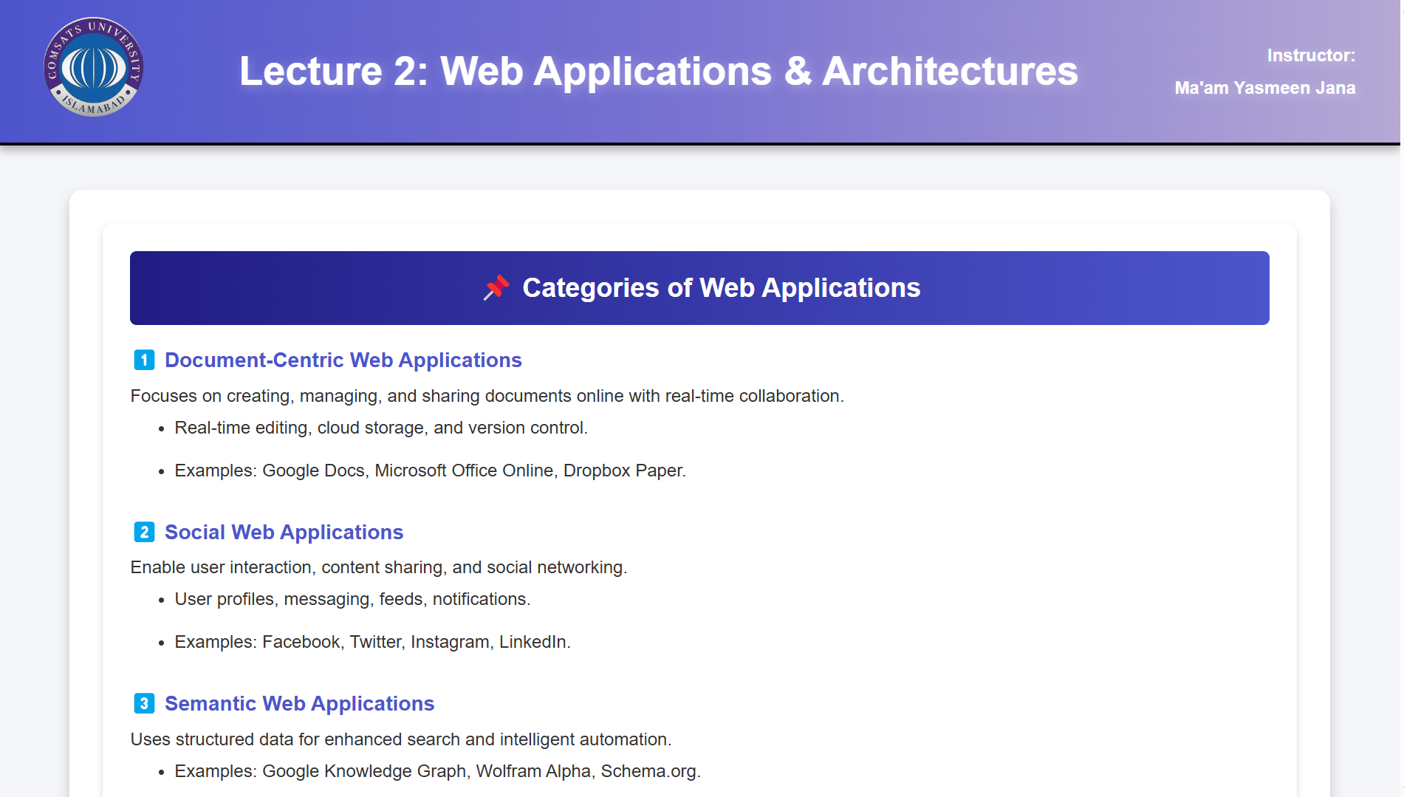

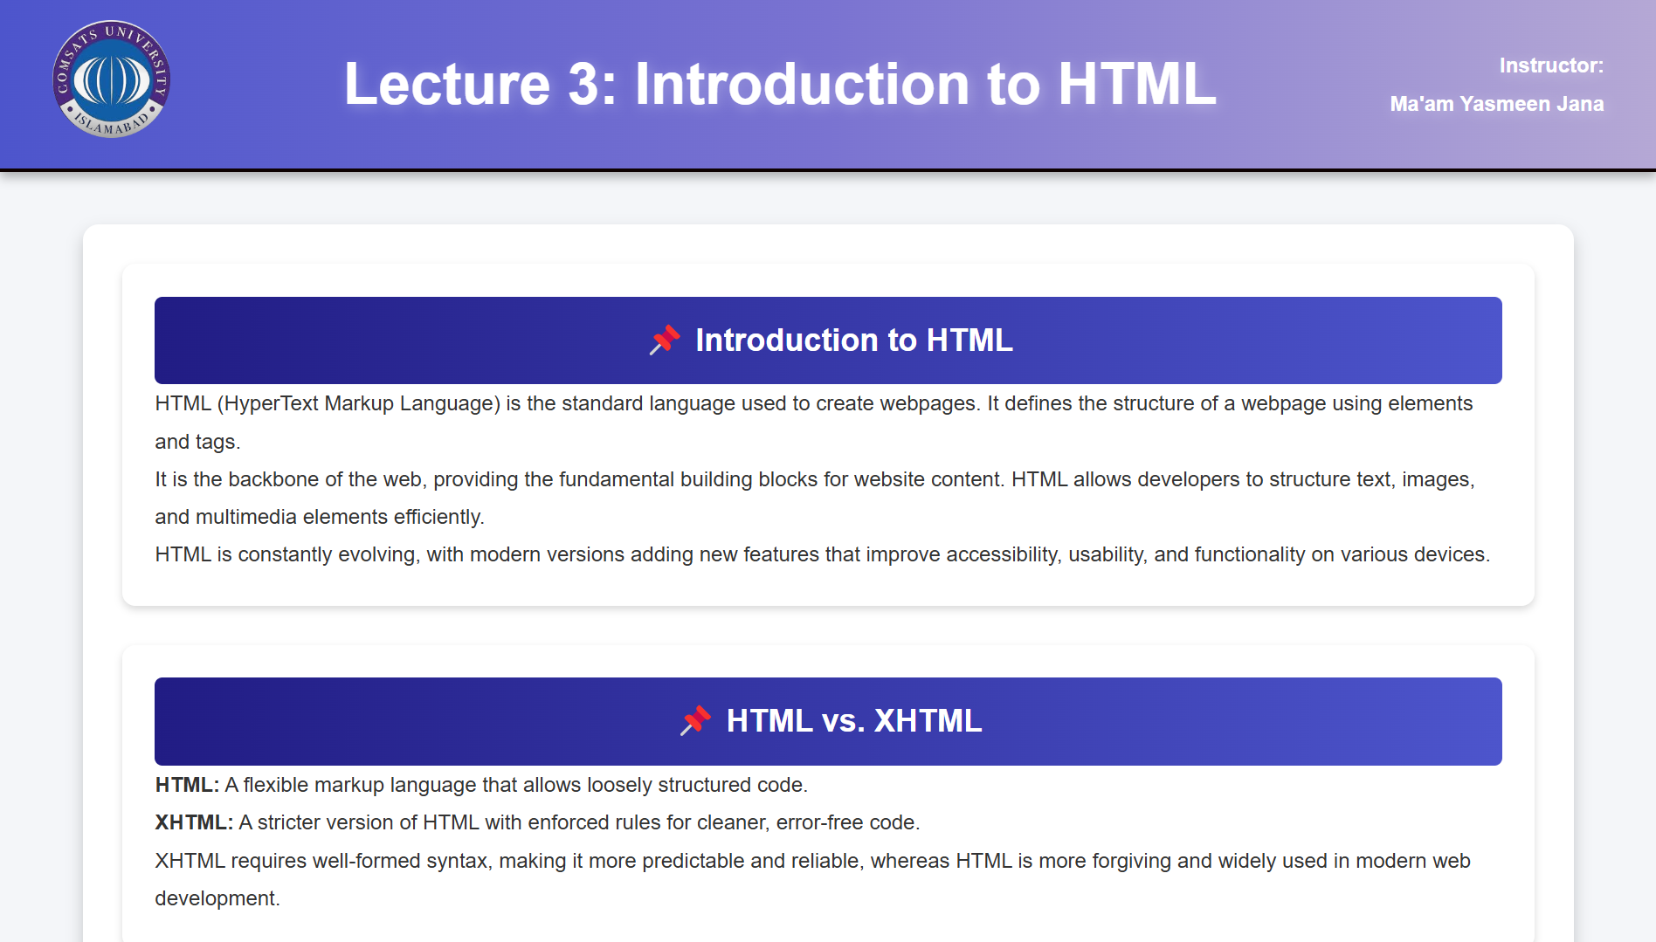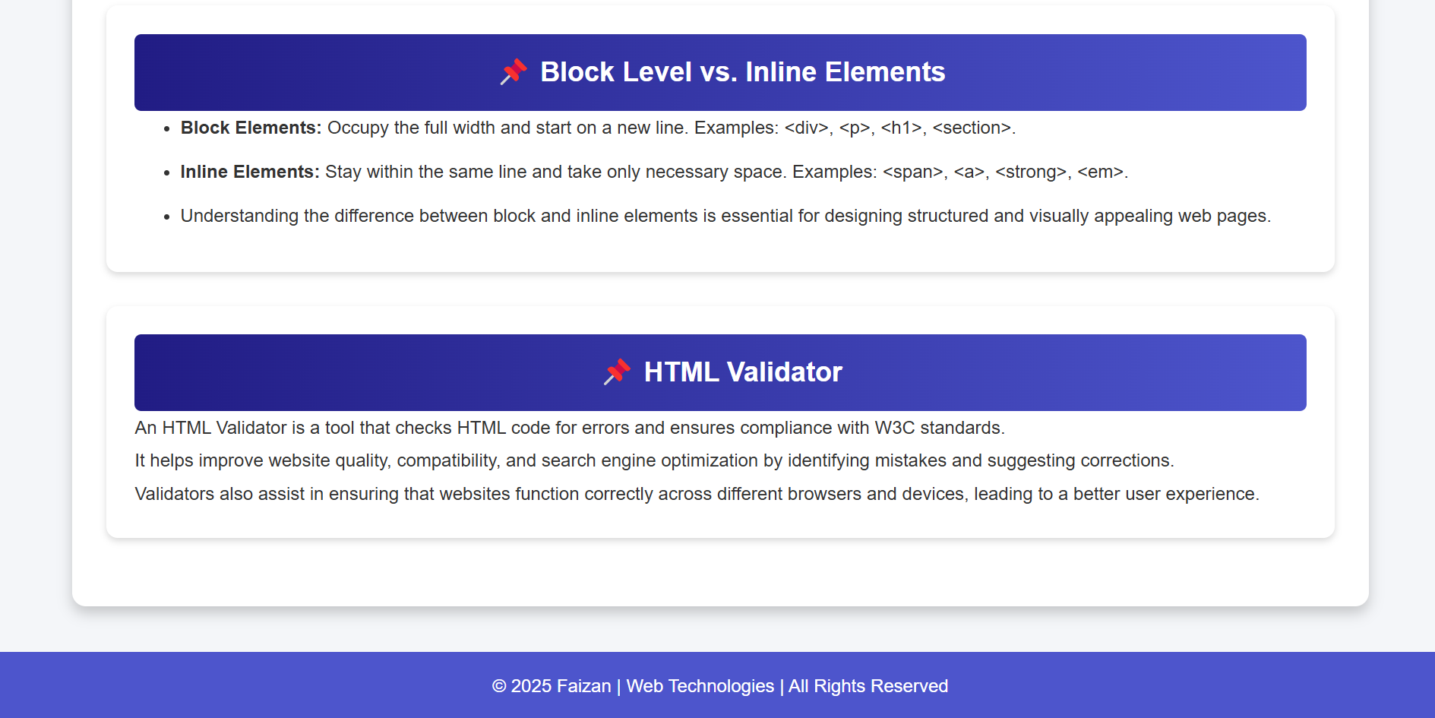

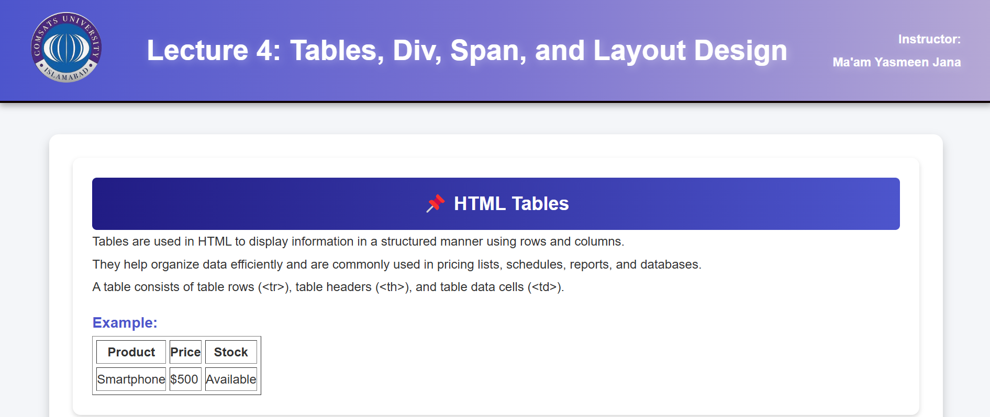

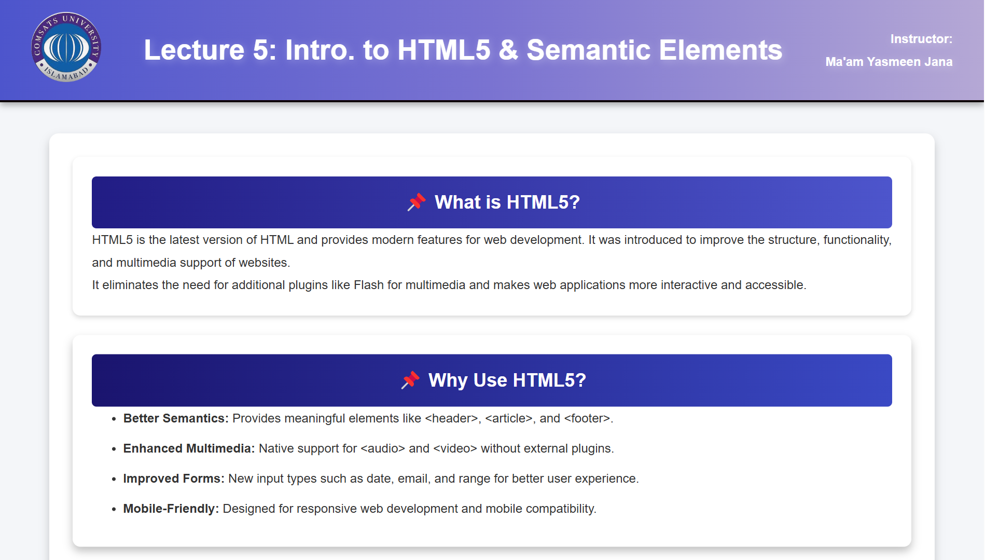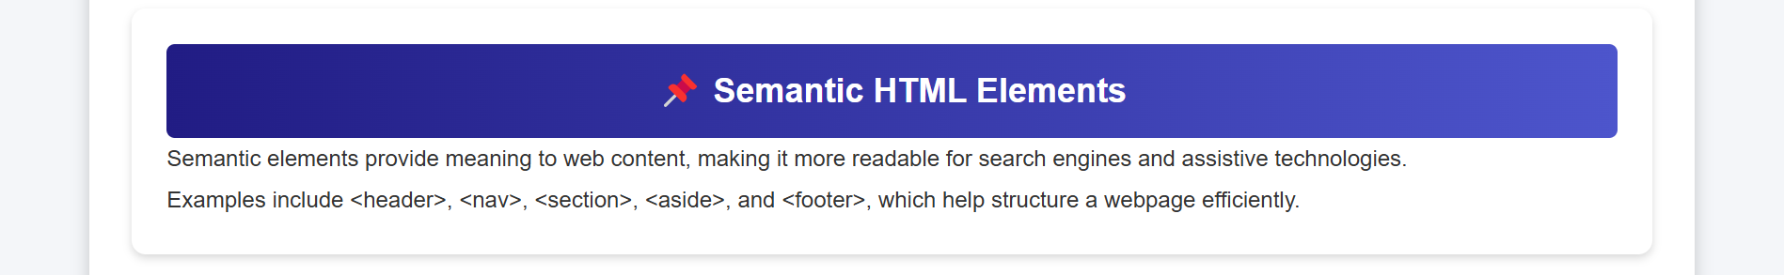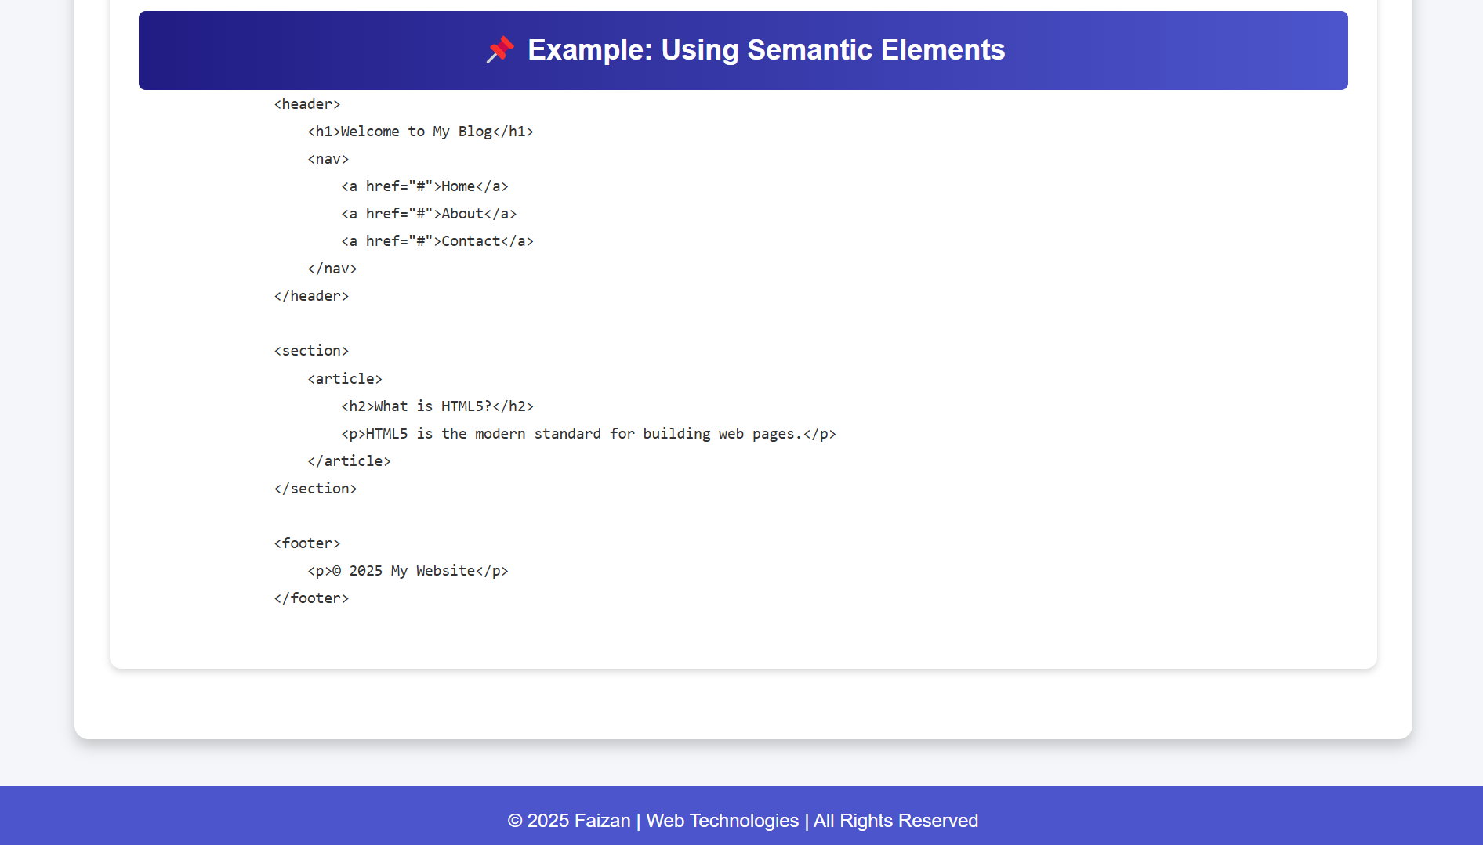

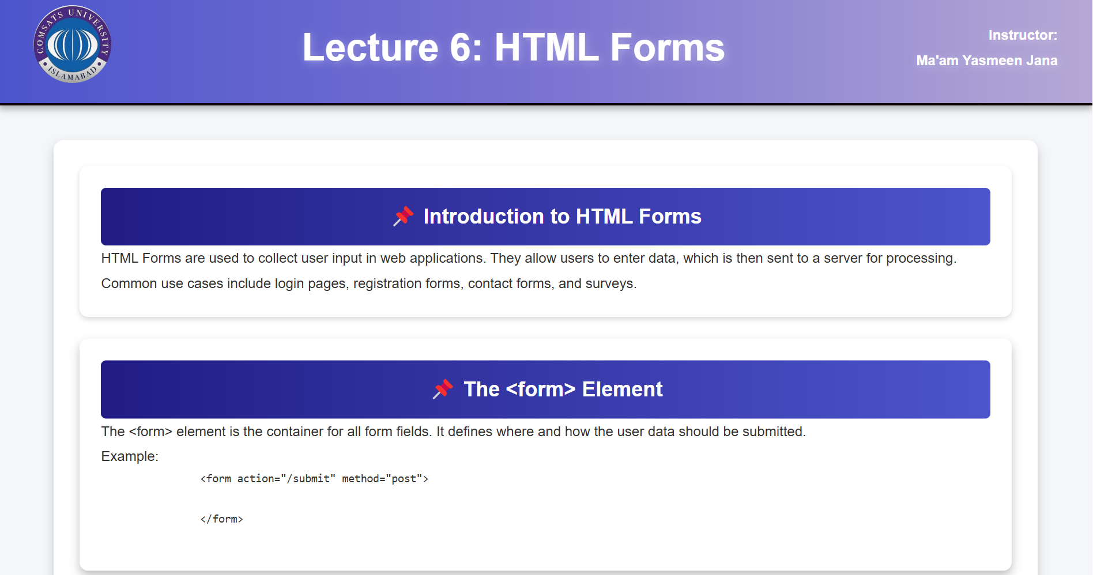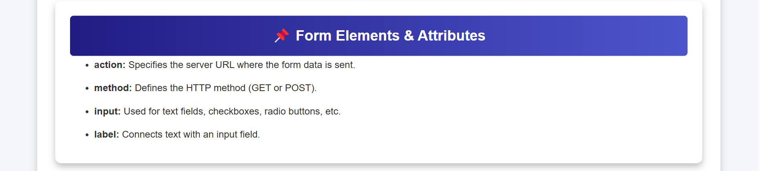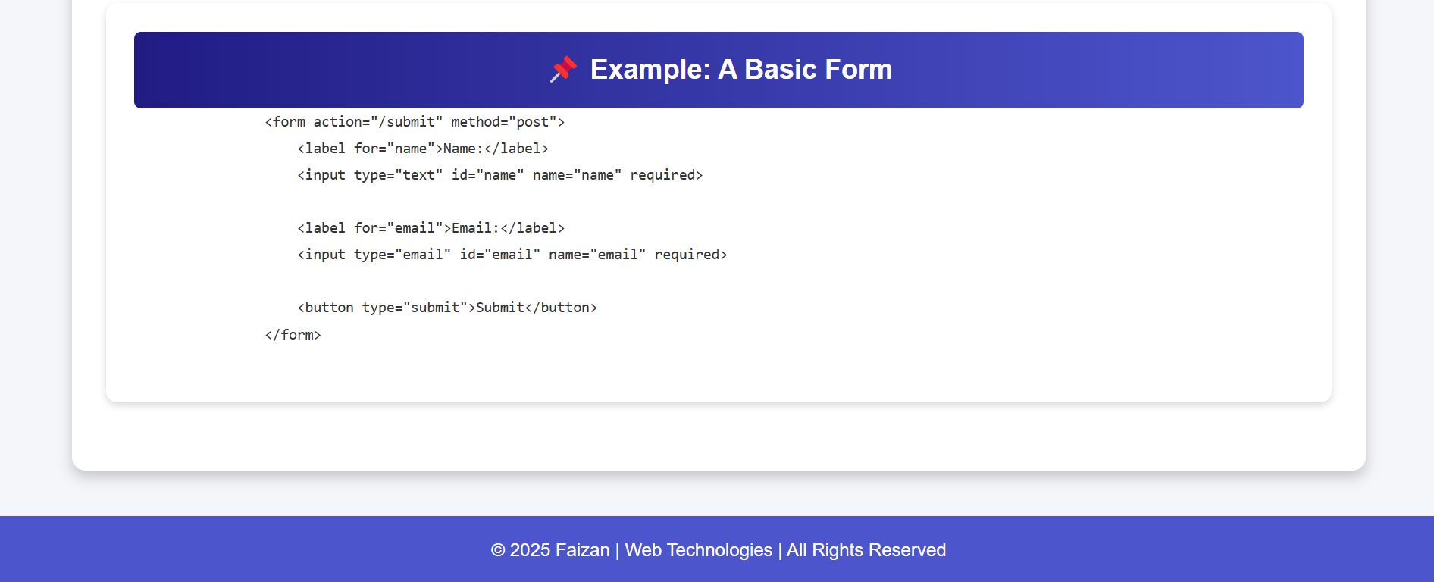

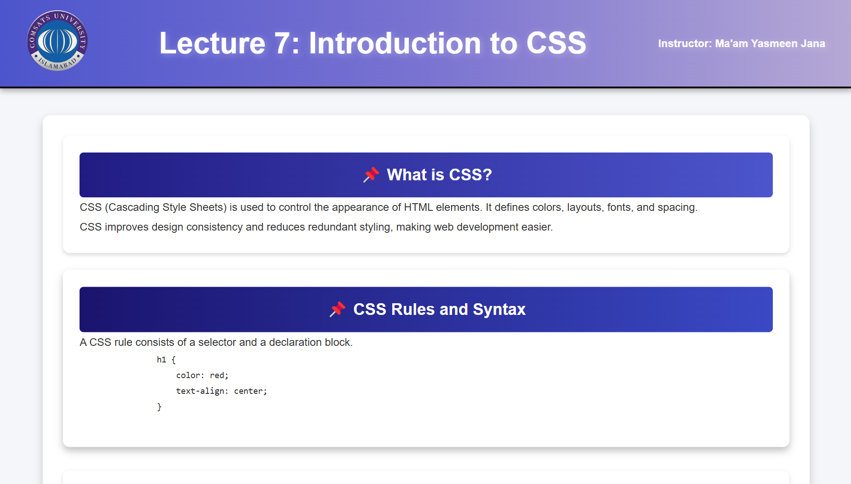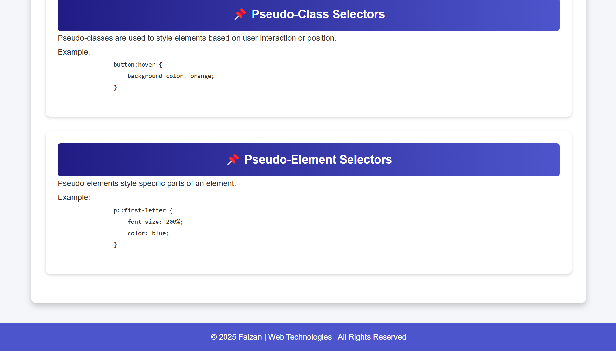

**References :**

1. **ChatGPT:** OpenAI. (2025). *ChatGPT (Version 4.0) [AI model].* Available at: <https://openai.com/chatgpt> [Accessed 13 March 2025].
2. **DeepSeek**: DeepSeek AI. (2025). *DeepSeek AI [AI model].* Available at: <https://www.deepseek.com> [Accessed 10 March 2025].
3. **Lecture Slides by Ma'am Yasmeen Jana:** Jana, Y. (2025). *Web Technologies - Lecture Slides.* Department of Software Engineering, COMSATS University Islamabad , Vehari Campus.
4. **Google**: Google. (2025). *Google Search Engine.* Available at: <https://www.google.com> [Accessed 11 March 2025].